Email Template for Employee Enrollment

How To Use This Template: Use this email template to promote this new app with your employees. Copy and paste the below language into your email platform. Fill in the highlighted fields with your company’s information and customize the email as you see fit. Send it to your employees to get them started on enrollment.

Aloha!

We’re excited to introduce you to the ProService COVID-19 Navigator powered by iHealthHome and MediKeeper.

This tool is a necessary and critical part of keeping our company healthy and safe as we navigate working in the era of COVID-19. Beginning [enter date], every employee must complete the screening questionnaire each day of the scheduled work - even if you aren’t coming into the worksite/office.

In this email, we are sharing what you need to know as we adopt this new tool to keep everyone safe.
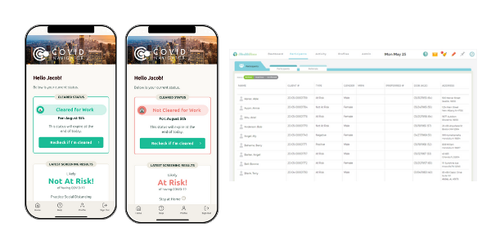
Here’s a brief overview:
- The ProService COVID Navigator is a mobile app that streamlines the health screening process.
- All employees will take a health questionnaire from home, even if not coming to the office. The questionnaire will display a “Cleared for Work” or “Not Cleared for Work” badge based on your answers.
- If you’re not cleared to work, employees can follow-up with their [Supervisor? Manager?] or [enter name(s) of your selected employer administrators] for further instructions.

Ready to get started? Here’s what to do:
- Step 1: Download the COVID Navigator app from the App Store or the Health Navigator app from Google Play (Note: The app has two different names).
- Step 2: Open the app and enter the Group Code:[Enter your company’s group code here] (It’s case sensitive)
- Step 3: Register yourself on the app.
- Step 4: Complete the initial Screening Questionnaire
- Step 5: Open the app each day and complete the “Check if I’m Cleared for Work” (Note: You’ll need a thermometer to take your temperature).

Resources:
- Watch this video about how to get started.
- Use this guide to step-by-step instructions for getting started on the app.
- Questions? Read through these FAQs

Mahalo,
[Company Name]

